1.
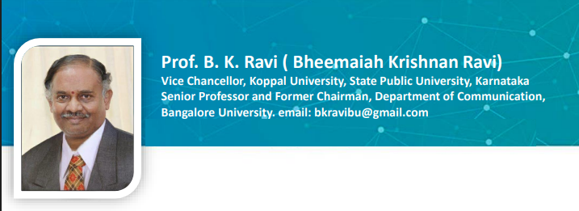
2.

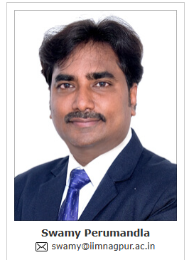

Professor. Swamy Perumandla is Chairperson and Professor in the Finance and Accounting Area at Indian Institute of Management Nagpur (IIM Nagpur), Maharashtra, India. He has over 13 years of teaching, research, executive learning, and training experience at various management institutes in India. He published several publications in ABDC, SCI and SSCI in reputed journals reflecting his significant academic contributions to the field. He earned his Ph.D. in Finance from the National Institute of Technology Warangal (NIT Warangal), India. He also qualified for the National Eligibility Test (NET). He is certified as an IICA (Indian Institute of Corporate Affairs) Resource Person. Additionally, he served as a SEBI empanelled financial education Resource Person.

3.
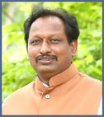 | Prof. D. Sreeramulu  MBA,LLB,PhD  Senior Professor (Marketing & G.Mgt)  Department of Management  OSMANIA UNIVERSITY, Hyderabad  Telangana, INDIA.  30 Years of Teaching Experience  6 Scholar Completed PDF  30 Scholars Awarded PhDs  82 Articles Published in Journals  Authored 3 Books  Books Edited 10  NAAC Peer Team Co-Ordinator & Member  AICTE Inspection Committee Member  Projects Completed 2 (UGC & AICTE)  Email: profsreeramulu@gmail.com  Vidwan ID: vidwan.inflibnet.ac.in/profile/593964

4.
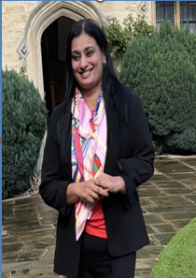
Dr. Sapna S is a Doctorate from the National Law School of India University (NLSIU), Bengaluru. She is currently serving as Dean, School of Law, Dayanand Sagar University, Bangalore.
Dr. Sapna is a distinguished Gender Consultant with the Department of Labour, Government of Karnataka, where she has made significant contributions to gender capacity building and legal advocacy. She led the initiative for the Menstrual Leave Policy for the Government of Karnataka and has been actively engaged in policy recommendations with the Karnataka Institute of Legal and Parliamentary Affairs. She has successfully conducted sensitization programmes on laws relating to Prevention of Sexual Harassment across 8 districts of Karnataka, and delivered 18 sessions for ISRO along with numerous training programmes for various private entities.

5.
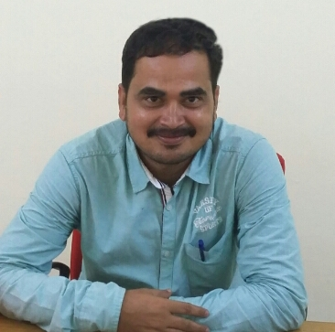

Dr. Gugulothu Srinu
Assistant Professor
Department of Public Administration and Policy Studies
18 Years of Teaching Experience
Central University of Kerala
Tejaswini Hills
Central University of Kerala (P O)
Kasaragod (DT), Kerala-671325
INDIA
Email: gsrinivas62@gmail.com

6.
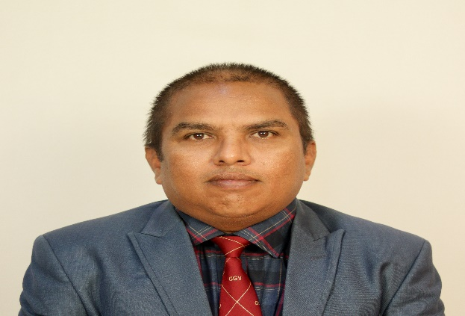
Dr. Vijaya Kumar
Assistant Professor
19 years of Teaching Experience,
Department: Pure & Applied Physics
Guru Ghasidas Vishwavidyalaya (A central University, act 2009), Department of Pure & Applied Physics, Koni, Bilaspur, Chhattisgarh, India.

7.
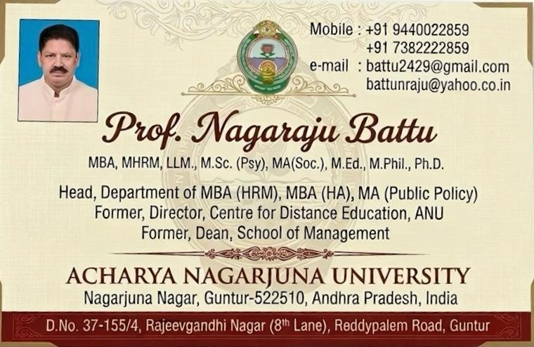

8.

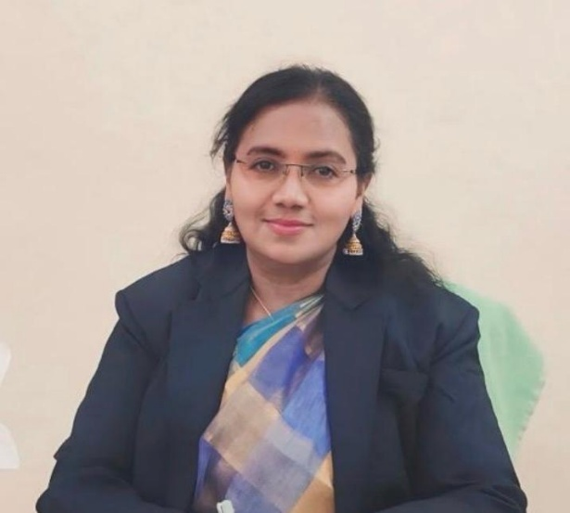

DR. K. SUVARNA LATHA
Ph.D. (Structural Engineering) · M.Tech · B.Tech (Civil)
Principal, Government Polytechnic for Women, Secunderabad
Department of Technical Education, Government of Telangana.
Email: latha_suvarna@yahoo.co.in

Teaching & Administrative Experience: 30+ years in technical education
Current Position: Principal, Government Polytechnic for Women, Secunderabad — Department of Technical Education, Government of Telangana
Her professional journey reflects dedication, integrity, innovation, and a strong vision for transforming technical institutions into centres of excellence. She has successfully led several academic, administrative, and infrastructure development initiatives that have significantly strengthened the technical education ecosystem in Telangana.

ADVISORY BOARD-NICE

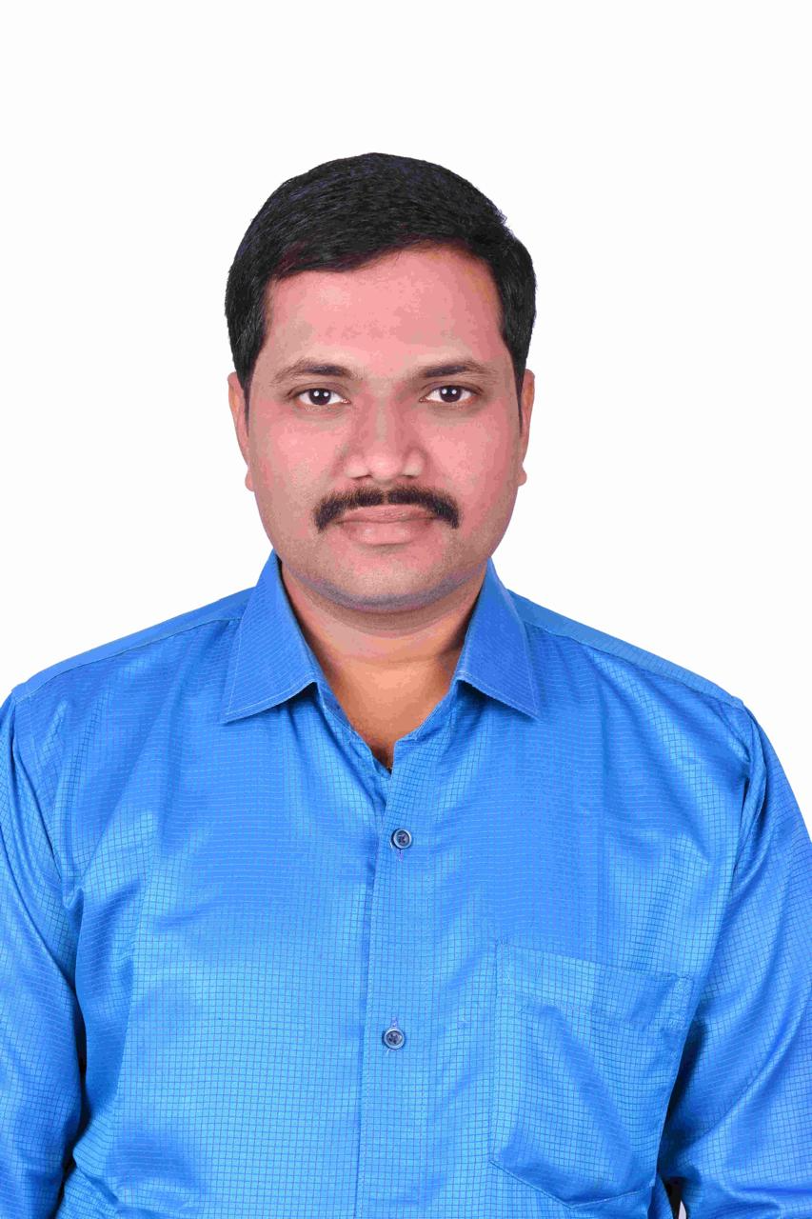
Email: prameshbabu526@gmail.com
Dr. P. Ramesh Babu is a distinguished academician, researcher, administrator, and technology leader with over 22 years of experience in higher education, research, academic administration, and industry-oriented training. He is currently serving as Professor at the C.R. Rao Advanced Institute of Mathematics, Statistics and Computer Science (AIMSCS), University of Hyderabad Campus, Hyderabad. Throughout his career, he has held several prestigious academic and administrative positions, including Professor, Associate Professor, Head of the Department, Vice Principal, NBA Coordinator, and Academic Council Member at reputed engineering institutions across India.

